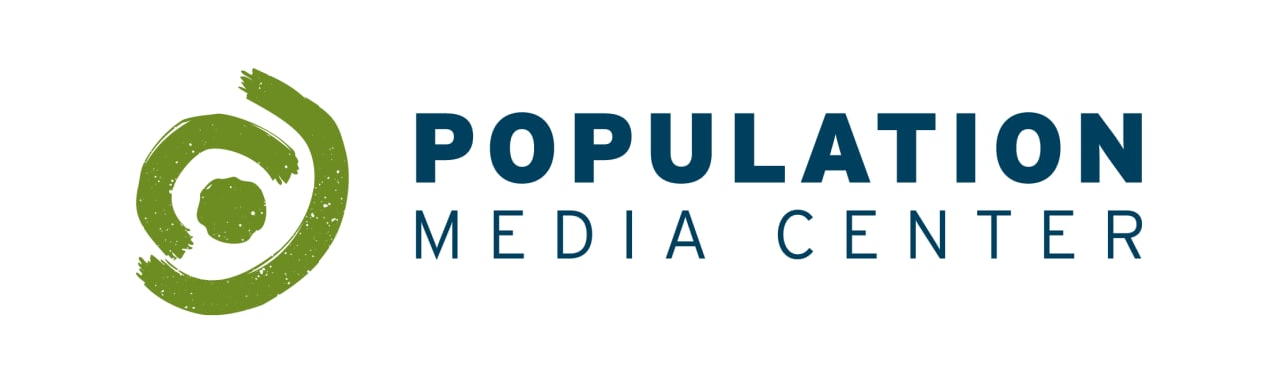
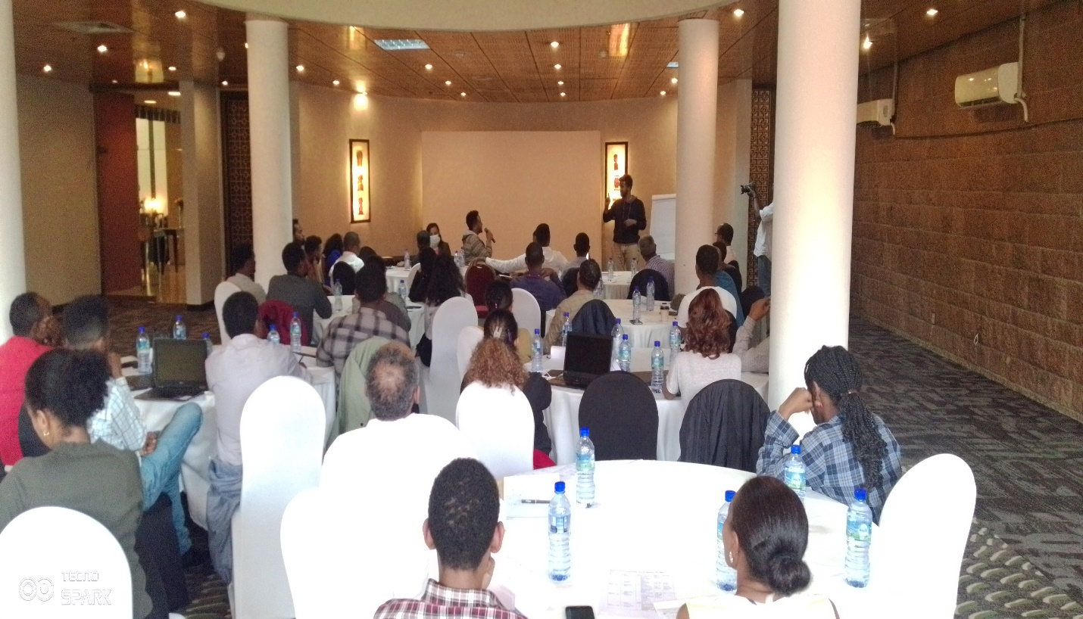
Disability Accelerator Training Report
Training Participants: SC core operation staffs and representatives from partners.
30 Aug-02 Sep 2022, Jupiter Hotel, Addis Ababa

Admasu Menitire
Project Coordinator
amentire@populationmedia.org
Population Media Center-Ethiopia
P.O. Box 672/Addis Ababa
Office: +251115157057/+251118723835

- Training Overview
In partnership with Save the Children, PMC is implementing two projects: NORAD and Irish Aid projects, in prevention of negative gender norms-FGM and child marriage in lowland areas in Ethiopia- 22 woredas in Somali and Afar regions. To address the practices and bring positive attitudinal changes among the communities in the project woredas, PMC-E is implementing diverse media related interventions, campaigns, capacity building activities, and networking with the stakeholders.
Save the Children conducted training for its core operational areas staffs and representatives from implementing partners including PMC, on Disability Accelerator Programme at Jupiter hotel Addis Ababa, between Aug 30-Sep 02.
The training has a paramount role for PMC, in identifying and addressing children and adults with disability in its interventions and maintaining of inclusive programing’s.
As it may be recalled, PMC has experience in addressing issues of disability inclusiveness in some of its media programs such as including sign-languages during production and broadcasting of different TV Spot Messages and others. The training gave an insight on how to approach barriers and enablers of inclusion under thematic areas, especially in addressing of negative gender norms. Moreover, the training gave an opportunity to explore the current Models of Disability Inclusion, which model is being exercised in Ethiopia, and major commitments expected from each partner to Disability Inclusion.
On the training, multiple organizations working on people with disability (OPD) were invited and shared their experience in maintaining and addressing of Disability Inclusion, Disability Rights of children with disabilities, and their experience in addressing of barriers.
- Training Objectives
The training was conducted with objectives.
- To create understanding on concepts around disability, disability rights, inclusion, and barriers
- To create awareness on awareness of discrimination faced by children with disabilities
- To create understanding on Inclusive Programming- Applying Inclusive Programming Principles, and inclusive MEAL
- To establish connection with OPDs (organizations working on Peoples with Disabilities)

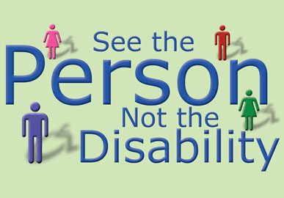

- Training Summary
  - Disability- Background
Disability technically defined as-people who have long-term physical, mental, intellectual, or sensory impairment which, interaction with barriers within the society may hinder their full and effective participation in society on an equal basis with others.
- Impairment - are defined as limitations in body function or structure such as a significant deviation or loss. The impairments may be-lacking a body part or mechanism that doesn’t fully function, long-term or short-term, physical, sensory, neurological, intellectual, or psycho-social
According to recent data presented on the training, globally, 240 million children are living with disability worldwide, among them:
- Only 10% of children with disabilities go to school in low- and middle-income countries, and 30 % of out of school children are children with disabilities
- Only 5-15% of children and adults who require assistive devices and technologies have access to them
- 3-4 and more of them are likely to experience abuse
- Children with disabilities are 3 times more likely to be underweight and nearly 2 x likely to experience stunting and wasting.
- People with a disability more commonly report selling land and other assets to cover health costs
- People with disabilities and their families are likely to experience greater exposure to shocks/stresses/hazards and increased vulnerability to deal with it
- People with disability are less resilient WHEN a shock or stress occurs
  - Gender and Disability
- Prevailing gender norms and patriarchal structures apply also to girls and boys with disabilities
- Women with disabilities are 2-4 times more likely to experience intimate partner violence.
- Findings show that, 19% of women have a disability in comparison to 12% of men globally
- Girls and boys with intellectual and psychosocial disabilities are more vulnerable to sexual violence in humanitarian contexts, due to a lack of: information about gender-based violence; awareness of personal safety; and weaker or no protective peer networks
- Women with disabilities are three to four times more likely to be HIV-positive
- The global literacy rate is 3% for all adults with disabilities and 1% for women with disabilities
  - Disability, poverty, and exclusion- Nexus
- Disability causes poverty, poverty causes disability
- Persons with a disability are often a neglected and discriminated group within development.
- Poorer chances for: Employment, education, Social Justice, health services, Participation
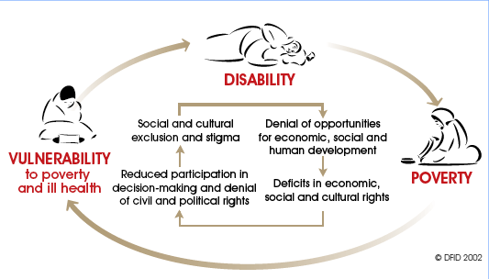
  - Enhanced child protection risks for children with disabilities
- Mothers abandoned at birth
Particular vulnerabilities
- Harder for child to be aware of maltreatment
- Harder for child to identify inappropriate touch
- Girls are more vulnerable
- Intellectual, deaf, blind & deafblind added risk
- Disability does NOT equal protection issue
- Beaten and punished
- Neglected, left alone, ignored, without food
- Chained or tied up
- Sexually abused (harder to ward off and warn)
- Exploited or forced to work/serve
- Over protected
- Left uninformed/ unaware
- Poor health and infections
- Forced sterilization
- Children are killed, abandoned, or institutionalized
- Reduced sentences for murder ‘mercy killings’
- Mothers abandoned at birth
- ‘unreliable’ witnesses = denied access to justice
  - Barriers in the society
Attitudinal: Misperceptions about needs, capacities, and rights. Cultural and social habits, Stigma, Prejudices, Pity and etc.
Environmental barriers in nature or built environment: No accessible toilets, water points, thresholds, lightning, sound levels
Institutional: Discriminative Policies, strategies, legislations, or the absence of policies to subsidize serviced or access
Communication/Informational: the absence of adapted communication or information such as braille, radio, large print, word by mouth, home visits, sing posters, images etc.
  - General Principles-UN Convention on the Rights of Persons with Disabilities
- Respect for inherent dignity, individual autonomy including the freedom to make one’s own choices, and independence of persons
- Respect for the evolving capacities of Children with disabilities and respect for the right of children with disabilities to preserve their identities
- Non-Discrimination
- Full and effective participation and inclusion in society
- Respect for difference and acceptance of persons with disabilities as part of human diversity and humanity
- Equality of opportunity
- Accessibility
- Equality between men and women
- Disability Policy
The disability inclusion policies of any organization working within the community should address peoples with disability setting measures on lifting of social barriers and maintaining of equality. Most importantly, the disability policy should pinpoint:
- Leaving no child behind: Closing the gap on inequalities and discrimination
- Promote the inherent dignity, individual autonomy and independence of both adults and children with disabilities
- Recognize that disability is one aspect of identity, and that many individuals with disabilities identify as part of a global disability community
- Work with children with disabilities and children of parents/caregivers with disabilities
- Commit to programme, advocate, partner and organize for disability inclusion work with children with disabilities and children of parents/caregivers with disabilities
- Our interventions should be equitable, accessible, and inclusive
  - Inclusive Child Protection

- Major commitments expected to ensure disability inclusion
- Programme with and for the Children with Disabilities
Design and deliver Disability Inclusive PROGRAMMES, where:
- Families and children with disabilities can equitably access, participate in, act as decision makers for, and benefit from our programmes on an equal basis with others and
- Children and families with disabilities are specifically targeted and supported to reduce their experience of exclusion and discrimination.
- Disability Inclusion Programme Guidelines, Data and Accessibility (forthcoming)
- Organization’s office Self-assessment on Disability Inclusion (forthcoming)
- Disability Inclusive Child Safeguarding Guidelines and Toolkit
- Advocate with and for children with Disabilities
- Promote, protect, and uphold the rights of children with disabilities of all genders through ADVOCACY
- Support children with disabilities as child rights defenders and to engage in national, regional, and international child rights reporting mechanisms
- Expand the evidence base for inclusive programming across themes, including but not limited to the collection of Disability Disaggregated Data (DDD)
- Support duty-bearers to meet their human rights obligations
- Use empowering images and language that celebrate diversity
- Create Disability-Confident WORKPLACE
- Create accessible, inclusive, and equality-centered working environments
- Create a diverse and disability-confident WORKPLACE that actively recruits persons with disabilities of all genders to ensure that our leaders, staff, volunteers, and advisors represent the communities we live and work in.
- Build a workplace culture where staff with disclosed or undisclosed disabilities feel supported and can effectively and safely carry out their duties.
- PARTNER with Representative Organizations of Peoples with Disabilities
Purposively PARTNER with persons, including youth and children, with disabilities and their representative organizations and networks. This can improve our technical capacity, ensure accountability to key stakeholders and to inform our programmes and culture.
- Planning, Monitoring, Evaluation, Accountability and Learning for Disability Inclusive Programming
Why inclusive MEAL?
- To design programmes that address and remove the barriers to participation and services experienced by persons with disabilities
- To know the extent of how our programmes actually benefit adults and children with disabilities
- To know how many adults and children with disabilities that benefit from our programmes and advocacy work
- To understand what works for adults and children with disabilities
- To share good practice on what works for adults and children with disabilities
- To allow adults and children with disabilities to share their views on our work
- To know how inclusive, we are as an organization

- Way forward
From the four days training, emphasis was given that, all peoples with disabilities should be effectively included on equal basis with others. Every organization working to alleviate the social problems within the community should create awareness disability rights, promote the overall participation of persons with disabilities in its interventions at grass root and within the organization, and develop a strong documentation starting from identification, reporting and institutionalization of best practices on the thematic area. Some of the major way forwards from the training are:
Implementing partners and organizations working on Peoples with Disabilities (OPD) should:
- Focuses on the elimination of barriers faced by persons with disabilities and enabling their meaningful participation.
- Promote, protect, and ensures their full and equal enjoyment of all human rights and freedoms, without discrimination of any kind
- Focus on the capacities of persons with disabilities, by placing emphasis on creating an enabling environment
- Support child and family to understand and accept disability
- Work with service providers and community to not discriminate/ exclude
- Work to remove physical barriers to services/ facilities/ access points
- Create a strong inclusive MEAL; through documentation, inclusion of reporting formats and addressing people with disabilities accordingly.

